Persuading the Polarized Juror in Sex Abuse Cases

Shelley Spiecker, Ph.D.

INTRODUCTION

We live in unique times politically and socially. People – including jurors – are more polarized and opinionated than ever. This fact carries a number of implications for litigators. Simply by following the news and our own social-media accounts, we know we live in an era of increasing complexity and competition when it comes to persuading others. Facts are not easily accepted, but rather, questioned and internalized based on beliefs, emotions, and social affiliations that often go unacknowledged or underappreciated.

As legal professionals we must be sensitive to how people form their opinions about sexual abuse. Today’s climate requires continuous exploration of persuasive resistance in the context of legal decision making to identify the best ways to overcome these challenges. The four elements of persuasive resistance explored in this paper are: 1) Dominant Narrative; 2) Authoritarianism; 3) Fear; and 4) Tribalism. In addition, this paper explores the unique characteristics of the largest generational cohort sitting on juries today – Millennials – and how this cohort is likely to view the unique issues in sexual abuse cases.

DOMINANT NARRATIVE

A Dominant Narrative is a story we tell ourselves to explain phenomena we encounter in the world. These powerful stories shape our perceptions of reality and govern our responses. For example, if we think Whole Foods is too expensive, we will discount or ignore examples where Whole Foods is actually cheaper than other grocery stores. Traditionally, there have been several dominant narratives surrounding sexual abuse that have worked against victims who bring lawsuits. Drawing from the ‘rape myth’ literature (for example, see Shona Mcintosh & Josh P. Davis, The ‘Casting Couch’ Scenario: Impact of Perceived Employment Benefit, Reporting Delay, Complainant Gender, and Participant Gender on Juror Decision-Making in Rape Cases, PsyArXiv (Aug.19, 2019).), three of these dominant narratives include:

- Victim Blaming: The victim must have mistakenly or intentionally put him or herself in a position of vulnerability or happened because the victim participated in a high-risk/low-morality lifestyle.

- Abuse Justification: The perpetrator must have perceived that the victim was ‘okay’ with sexual advances.

- Allegation Veracity: If the alleged victim took time to report the abuse or has an inconsistency in their ‘story’ then the abuse may not have happened, or ‘something’ might have happened but it was not sexual abuse as defined by the law.

Currently, the Me Too Movement has created a dominant narrative counter to the aforementioned ‘rape myth’- inspired dominant narratives. Numerous women coming forward, oftentimes years after experiencing sexual harassment or even rape, has raised our social consciousness to abuse.

One recommendation is to interject the Me Too narrative into a case at the time of jury selection. Asking prospective jurors about their thoughts about the movement (i.e. social awakening whose time is long overdue v. a bandwagon effect) will not only give valuable insight into a prospective jurors’ opinions but it will also interject a new dominant narrative into the case. In addition, the influence of dominant narratives is so strong that a dominant narrative does not need to be voiced to be invoked. Thus, do not shy away from introducing more traditional ‘rape myth’ dominant narratives in jury selection and asking jurors directly about them. Finally, instead of trying to fight against the established perception, whether accurate or inaccurate, litigators can accept and use the dominant narrative to disrupt a juror’s expectations in a positive way. For example, by harnessing the strength of the perception that victims must somehow invite abuse, in the case of a child victim a perpetrator can be perceptually even more egregious for introducing sexual advances to a naïve victim.

AUTHORITARIANISM

Authoritarianism is a psychological habit of respecting authority, the rules and one’s own in-group, which leads to predictable attitudes and actions. The phenomenon of authoritarianism has been studied extensively in the context of the jury and the findings reveal that jurors with a proclivity toward authoritarianism are significantly more likely to:

- Give strong presumption to conventional beliefs.
- Focus more on punishment as the goal, as opposed to justice, both in the civil and criminal context.
- Give less support to civil liberties.
- Base decisions on perceived similarities between themselves and a party or a witness.
- Place blame on a single party in a civil case, rather than distributing blame among parties.
- Side with the party with the greater social prestige.
Given the facts of a particular abuse case, you may want to identify and deselect authoritarians. This would be true, for example, if the perpetrator was/is in a position of high authority or has been tried and convicted in a criminal proceeding. Research has found a strong correlation in views on parenting and views of childrearing and authoritarianism. Matthew MacWilliams studied authoritarianism’s role in predicting voters favorable to President Trump. His research found that just the following four questions reliably predicted an authoritarian personality: Did respondents feel it is more important to have a child who is respectful or independent; obedient or self-reliant; well-behaved or considerate; and well-mannered or curious? Matthew MacWilliams, The One Weird Trait That Predicts Whether You’re a Trump Supporter, Politico Magazine (Jan. 17, 2016).

While many consultants teach how to identify and deselect authoritarian jurors during jury selection, it is likely you will eventually need to persuade some authoritarians on your jury. The key to approaching any argument from an authoritarian perspective is to find the higher-order principle that is at play. If you have an individual making an abuse claim against a perceived corporation (e.g., school, religious institution), the authoritarian juror is primed to trust the large body and distrust the individual. To persuade the authoritarians, you will need to reframe the argument. For example, say, "It's not about the individual (i.e. the Plaintiff), it's about the principles of trust and respect. The order of society depends on the ability to be treated with trust and with respect. In this case the individual was asserting her right to sue, but really what's at stake is the survival of our ability to rely on those we trust and their respect to return that trust in kind with trustworthy behavior.” When it comes to a specific case, it is a matter of asking, "What am I fighting for, what's the larger principle at risk?"

FEAR

Fear is another strong motivator in a polarized society. Fear motivates people to hold a position because it increases feelings of security and reduces feelings of dread. Fear is a strong motivator due to what psychologists call the 'Locus of Control,' or the perception that one determines the events and outcomes that occur in life. For example, compare deaths related to gun ownership and deaths related to terrorism. Gun owners believe that when they have the gun, they keep it safe, their kids know not to use it and they're going to use that gun to protect themselves from other people with guns. They place the locus of control within themselves and feel gun rights promote safety rather than vulnerability as a result. Terrorism, on the other hand, is the bolt from the blue. How do you protect yourself from someone with a van driving on a crowded bike path? The lack of control promotes greater fear of terrorism even the data suggests that life-threatening risk is much more likely to come from an American firearm than a terrorist act.

The individual and community experience tells us that the media contributes to our perceptions of fear and threats to safety. Seventy-four percent of Americans surveyed said that most of their knowledge about sex offenders comes from the news media. Center for Sex Offender Management, Exploring Public Awareness and Attitudes About Sex Offender Management: Findings from a National Public Opinion Poll, (2010). Jane Weatherred has studied the role of media coverage of child sexual abuse. Her research gives insight into how perceptions of the problem of abuse have been shaped by media coverage. She divides media coverage of sexual abuse into five stages. She identifies the current stage of media coverage as focusing on high-profile institutional cases, such as sexual abuse within the Boy Scouts and at Pennsylvania State University. She views “institutional accountability” as the predominant media theme of this era. This follows a focus on religious institutions during the 2000s, during which news coverage emphasized how abuse had been covered-up for many years. Jane Weatherred, Child Sexual Abuse and the Media: A Literature Review, 24 J. of Child Sexual Abuse 16 (2015).

When looking at only the proportion of respondents who believe child molestation is “a serious problem” in various domains, religious institutions stand out as the only type of organization in which a majority of respondents (53%) believe sexual abuse is a major issue. Forty-one percent say the same of the film/music industry, 29% believe child molestation is a serious problem in child-education centers like school and camps, 23% view it as a serious issue for sports teams, and only 16% say the same of the places where they have lived. Additionally, slightly more respondents say sexual abuse is a serious issue in urban areas (27%) than in rural areas (22%). YouGov, Leaving Neverland, (2019).

Older generations who lived through the 2000 – 2009 era of media coverage of sex abuse scandal in religious organizations are more likely to say sexual abuse in religious institutions is either a “serious problem” or “somewhat of a problem.” Overall, 66% of Millennials, 74% of Gen Xers, 86% of Boomers, and 85% of Traditionalists endorse that belief. Increased educational attainment also appears to be relevant to public opinion of the prevalence of sexual abuse in religious institutions. Sixty-eight percent of people with a high school education or less, 77% of those who have taken some college classes, 85% of individuals with a bachelor’s degree, and 86% of those who have completed post-graduate education say it’s a problem. Id.

When representing victims of sexual abuse there is research to suggest that harnessing fear of threats to safety is a smart strategy. The book titled, Reptile: The 2009 Manual of the Plaintiff's Revolution, by David Ball, a trial consultant, and Don Keenan, a well-regarded plaintiff's attorney, provides an explanation for the role of fear in litigation. The advice boils down to trying plaintiff's cases by portraying the defendant's conduct as a threat to the safety of a community as a whole and not just to one individual victim. The theory is that, through those threat appeals you awaken the "reptile brain" within jurors and their motivation to protect themselves and their families. The resulting fear incentivizes the jury to find for the plaintiff.

If the metaphorical reptile can be awoken by a threat to the community, then it can also be mollified by the notion of a defendant already committed to safety. For example, in an abuse case, a defendant routinely wants to talk about all of the policies and procedures they had in place designed to prevent abuse. A plaintiff attorney would be wise to then point out that clearly the policies are not enough to protect the public given the plaintiff victim’s experience.

TRIBALISM
Tribalism is a fourth contributor to persuasive resistance. Identification with social groups is a powerful influencer that shapes beliefs and behaviors. Families, religious organizations and ethnic groups give individuals a sense of value and community. Before jurors ask themselves, “What do I think about this attorney’s argument,” they implicitly ask, “How will my agreement or disagreement with this argument impact my identification with my tribe(s)”? Obviously in sexual abuse cases, identification with a religious institution, social organization, sporting group, and even law enforcement are critical tribal associations to explore. Unfortunately, because the desire to be perceived as fair and impartial by prospective jurors during the jury selection process can be strong, getting honest answers about the impact of tribal associations can be difficult in oral voir dire.

Fortunately, however, lawyers can conduct social-media research on witnesses, parties and potential jurors to understand the key social groups that may affect a juror’s perceptions in a case. People frequently share their thoughts about the world via their social-media accounts. For example, in an excessive use of force case involving a police officer, a prospective juror was voicing an opinion that the plaintiff attorney wanted to hear. In contrast, her Facebook photo was a picture of the American flag and she had active “likes” to several organizations akin to the Blue Lives Matter movement, suggesting she might be a high-risk juror for the plaintiff in the case.

With regard to opinions of sexual abuse in particular, religious tribal affiliation is particularly influential. Thirty-seven percent of respondents to an Economist/YouGov poll conducted in February 2019 said that sexual abuse of minors is more common in the Catholic Church than in other religious institutions. A third of respondents say it is as common, and only 5 percent indicated sexual abuse is less common in Catholic churches. In contrast to the public as a whole, Catholics differ substantially in the perception of the issue, as 23% say sexual abuse is more common in the Catholic Church, 52% believe it’s as common, and 8% say it’s less common. Kathy Frankovic, How the Child Sex Abuse Scandal Impacts the Catholic Church – And Catholics, YouGov (Feb. 28, 2019).

MILLENNIAL ATTITUDINAL TRENDS
A. Millennials as a Defined Generational Cohort

While definitions vary, for the purposes of our research, we define Millennials as persons born between 1980 – 1996, aged 22 – 39 as of 2019. This is compared to Generation X jurors born between 1965 – 1979 aged 40 – 54 as of 2019, Baby Boomer jurors born between 1946 – 1964 aged 55 – 73 as of 2018, and Traditionalists jurors born between 1900 – 1945 aged 74 years or older as of 2019.

Because there are now more Millennials in the U.S. than any other generation, it is likely that Millennials’ influence on society will be noteworthy. Millennials have overtaken Boomers as the largest generation in the U.S. and will likely become even larger over time due to the influx of young immigrants. Richard Fry, Millennials Overtake Baby Boomers as America’s Largest Generation, Pew Research Center (Apr. 25, 2016).

Millennials are also now the largest generation in the work force. Just as the Baby Boomer generation impacted society based on the size of its numbers, so too are the Millennials likely to impact attitudes for the coming years. Richard Fry, Millennials are the Largest Generation in U.S. Labor Force, Pew Research Center (Apr. 11, 2018).

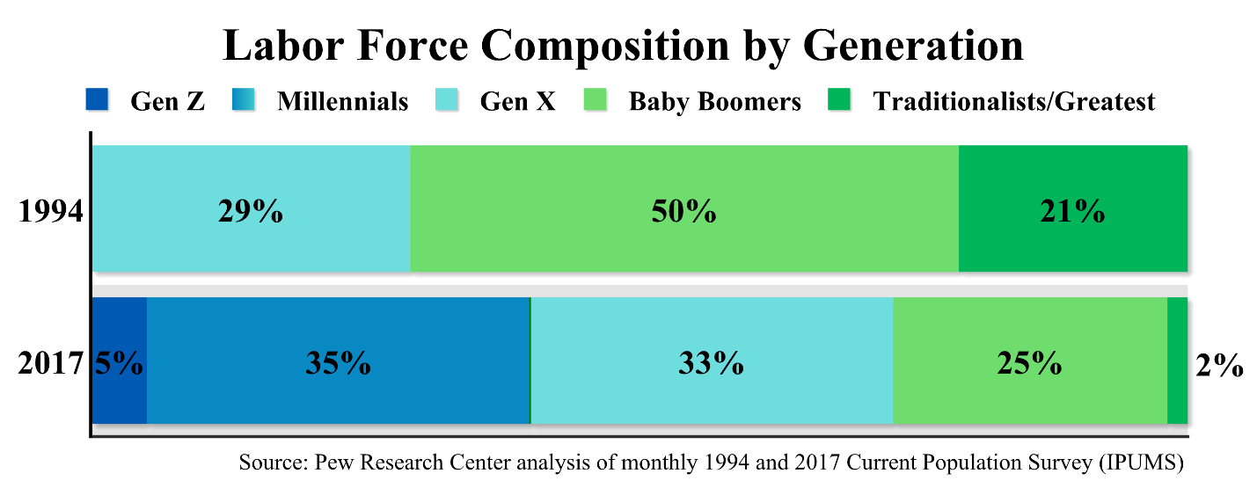

Figure 1. Labor Force Composition by Generation.

B. Millennials Seek Work and Life Balance

When it comes to work, Millennials are stereotypically thought to be more of a ‘slacker’ generation – less committed to career and less concerned about workplace success. Millennials tend to be less concerned with traditional ladder climbing and more concerned with integrating work and life – freedom and flexibility are important values. Millennials want to achieve, but they are focused on achieving different goals than previous generations. Rob Asghar, What Millennials Want in the Workplace (And Why You Should Start Giving it to Them), Forbes (Jan. 13, 2014). In 1976, 75 percent of Boomers said they expected work to be a central part of their lives, compared to 63 percent of Millennials in 2006. Jean M. Twenge, A Review of the Empirical Evidence on Generational Differences in Work Attitudes, 25 J. of Bus. and Psychology 201 (2010).

As evidence of this preference for flexibility, 77% of American Millennials say they have had to or would be willing to change jobs to better manage work and family or personal responsibilities, compared to 71% of Gen Xers and 49% of Boomers. When it comes to changing careers to have better work/life balance, 76% of Millennials say they have or would be willing to make the change, compared to 62% of Gen X and 44% of Boomers. Forty-four percent of Millennials have or would take a pay cut to have flexibility, as opposed to 35% of Gen X and 31% of Boomers. In fact, Millennials said they were more willing to make a change than other cohorts in regard to every sacrifice they were polled about, including giving up a promotion, moving to another location, and reducing their or their spouse’s hours. Global Generations: A Global Study on Work-Life Challenges Across Generations, EY (2015).

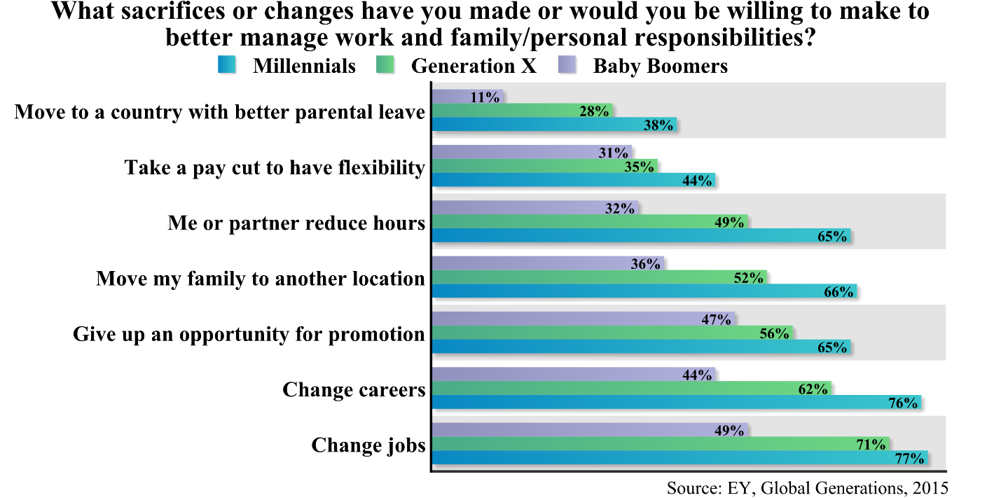

Figure 2. Willingness to Sacrifice for Work/Life Balance by Generation.

While life balance is a priority, it does not mean that Millennials are slackers. Eighty-seven percent of Millennials say that opportunities for professional development or career growth are very important to them – purpose and growth are common themes of Millennial work goals. Amy Adkins, What Millennials Want from Work and Life, Gallup (May 10, 2016). Kathleen Davis writes “Millennials are goal setters. To understand their ambition, just look at their pop-culture heroes: overachievers like Steve Jobs and Mark Zuckerberg.” Davis notes that while the stereotype depicts Millennials as irresponsible, on average they started saving for retirement four years before Gen X did, and 10 years before Boomers. Kathleen Davis, Five Secrets to Communicating Effectively with Millennials, Entrepreneur (June 13, 2013).

C. Millennials Gravitate Toward Optimism, Inclusivity, Liberalism, and Authenticity
in Communication and Work

Millennials are typically far more collaboration-oriented than competition-oriented. Eighty-eight percent of Millennials prefer a collaborative work culture rather than a competitive one. Rob Asghar, What Millennials Want in the Workplace (And Why You Should Start Giving it to Them), Forbes (Jan. 13, 2014). Desire for collaboration manifests in unmatched support for “big government” as the following Pew Research chart shows. Millennials in Adulthood, Detached from Institutions, Networked with Friends, Pew Research Center (Mar. 7, 2014). Millennials believe in more government services which they perceive have the ability to make a difference on both individual and societal levels.

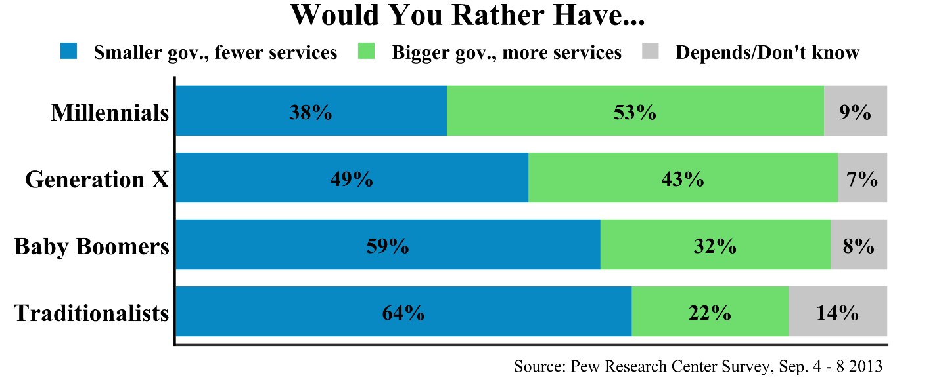

Figure 3. Support for Government Services by Generation.

Straight talk and passion are important elements to making a favorable impression on Millennials. Sixty-six percent of Millennials approve of business leaders who use straight-talking language. Millennials also have more highly-favorable attitudes towards leaders they believe are making efforts to be inclusive. A Preference for Plain Talk and Inclusiveness: The Deloitte Millennial Survey, Deloitte (2017). Marketers recommend avoiding Millennial skepticism by using every-day language instead of jargon. David Baker, Marketing to Millennials, (2016). Kathleen Davis notes that Millennials respond affirmatively to humor in communication, and she notes the popularity of memes for this generational cohort as one anecdotal example of the popularity of humor. She states that Millennials consume media that’s “goofy, earnest and confident.” If communicators can tailor their message with “quirk in an authentic voice” without pandering, Millennials may be more receptive. Kathleen Davis, Five Secrets to Communicating Effectively with Millennials, Entrepreneur (June 13, 2013).

Notably, Millennials as a generation are more optimistic than those that have preceded them. This is true despite the fact that the economy is not as friendly to Millennials as it has been to older individuals. Elena Holodny, Millennials Are Way More Optimistic About the Future than Baby Boomers, Business Insider (Apr. 28, 2016). Millennials were the only generational cohort to lose economic ground between 2010 and 2016, after the recession ended. This lower-wealth level is not due to shortfalls in income. Rather, it is the result of debt and homeownership. Many Millennials were too young to own homes during the Great Recession and they also racked up student loans, auto loans, and credit card debt. Interesting, however, they are the most education generation with the highest earning potential. Tami Luhby, Millennials Born in 1980s May Never Recover from the Great Recession, CNN Business (May 22, 2018).

Millennials believe they can have a positive impact on their lives, their peers, and society as a whole, and they desire to do so. As Svaldi notes, “What older generations may see as impatience — and even impudence — comes out of a belief they [Millennials] can make a difference and desire to be connected.” Aldo Svaldi, Millennials’ Perception of Hierarchy Flouts Unwritten Workplace Rules, The Denver Post (June 20, 2014). Additional support for the notion that Millennials gravitate toward inclusivity is evidenced by Millennials’ dislike of hierarchy, particularly in the workplace. Millennials want to be able to collaborate and feel heard, and are less interested in climbing ladders. They want to contribute without waiting to reach seniority. Brigid Schulte, Millennials Want an End to Hierarchies in the Workplace, The Washington Post (June 21, 2015).

While Millennials have been characterized as a particularly rebellious generation, this criticism is more likely than not unfounded. Millennial critics cite marrying late, foregoing home and vehicle ownership, and decreased allegiance to employers as examples of “rebelliousness.” In reality, these characteristics are more the result of pragmatic considerations and decreased options in response to downward trends in established markets than an ideological revolt. Laura Marsh, The Myth of the Millennial as Cultural Rebel, New Republic (Aug. 30, 2016). Millennials are the first generation in Modern American history faced with a lower standard of living than their parents. In fact, as Paul Taylor of Pew Research Center writes, “Millennials lag behind their same-aged counterparts of yesteryear on virtually all key indicators of economic well-being – including employment, income, wealth, debt and poverty.” Paul Taylor, Generational Equity and the Next America, Pew Research Center (Apr. 18, 2014). And economic trends such as high home rental rates, employers being less loyal to employees, and driving services such as Uber and Lyft have changed the options and opportunities facing this generational cohort.

Additional data refuting the rebellious stereotype comes from a survey reported in the Economist in which 5,000 individuals were surveyed and Millennials were most likely to agree with the statement, “Employees should do what their manager tells them, even if they don’t see the reason for it.” Forty-one percent of Millennials agreed compared to only 30% of GenX and 30% of Boomers. Myths About Millennials, The Economist (Aug. 1, 2015). Even though Millennials may not prefer strict hierarchies in the workplace, they still endorse the attitude that one should follow a dissenting decision of a supervisor at higher rates than other generations.

Millennials are more liberal than preceding generations. One example from our own proprietary survey research that supports the finding that Millennials are more liberal than other generational cohorts is the fact that Millennials are statistically significantly more likely to endorse the statement, “Society needs to do more to ensure people’s well-being,” over the competing idea more popular with Gen Xers and Boomers that, “People need to take more responsibility for their own well-being.”

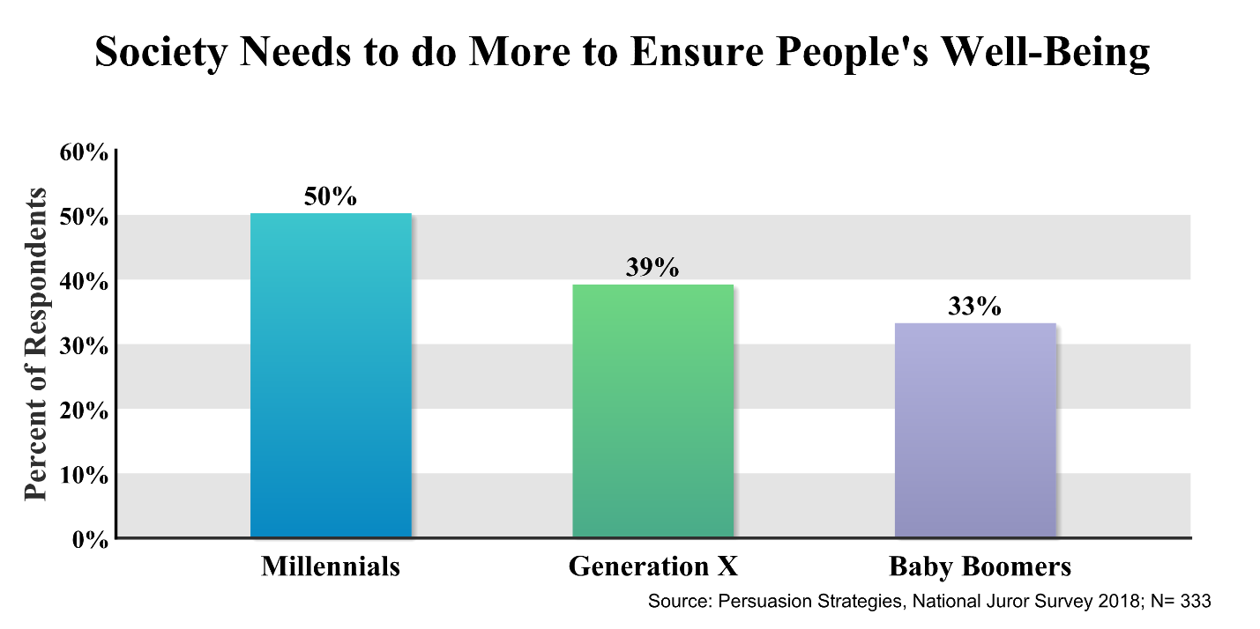

Figure 4. Society Needs to do More to Ensure People’s Well-Being

As another example of a more liberal bent, Figure 5 represents a statistically significant difference between Millennials/Gen Xers compared to Boomers and Traditionalists in their preference for ethics over the law when the two have the appearance of being in conflict.

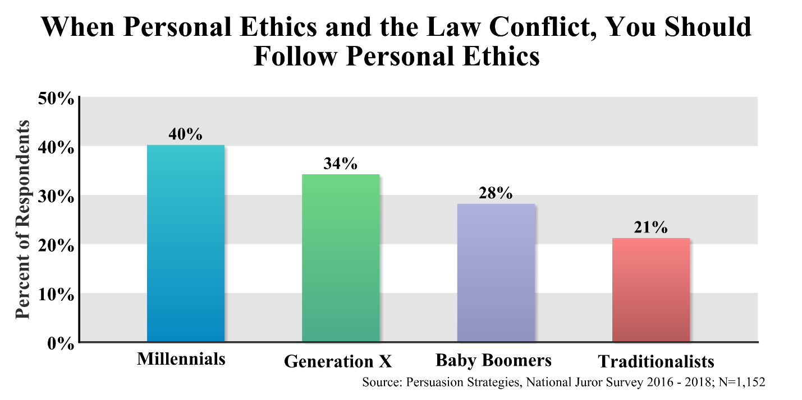

Figure 5. When Personal Ethics and the Law Conflict, You Should Follow Personal Ethics.

Millennials are also more independent thinkers than previous generations, on average. As the following table shows, Millennials are far more likely to identify as independent voters than prior generations, more likely to self-report no religious affiliation, and more likely to lean toward the liberal end of the spectrum on political issues, particularly political issues that have social implications. Millennials in Adulthood, Detached from Institutions, Networked with Friends, Pew Research Center (Mar. 7, 2014).

 | Millennial | Gen X | Boomer | Traditionalist
Political views have become* | % | % | % | %
More liberal | 48 | 42 | 35 | 24
More conservative | 42 | 48 | 53 | 57
No change/mixed | 6 | 6 | 10 | 10
Don’t know/refused | 4 | 4 | 3 | 9
Social views have become* | % | % | % | %
More liberal | 57 | 41 | 33 | 35
More conservative | 36 | 52 | 56 | 51
No change/mixed | 4 | 4 | 7 | 11
Don’t know/refused | 4 | 3 | 4 | 3
Considers self politically independent** | % | % | % | %
2007 | 40 | 36 | 34 | 29
2014 | 50 | 39 | 37 | 32
Religiously unaffiliated** | % | % | % | %
2007 | 26 | 18 | 50 | 69
2014 | 29 | 21 | 68 | 86
*Source: Pew Research Center Survey, Sept. 2014
**Source: Pew Research Center Surveys, 2007 and 2014

Notably, despite increasing political polarity in local and national elections, Millennials are the least likely generational cohort to perceive big differences between U.S. political parties. Id. This is likely due to a more pronounced distrust of politicians in general as compared to other generational cohorts.

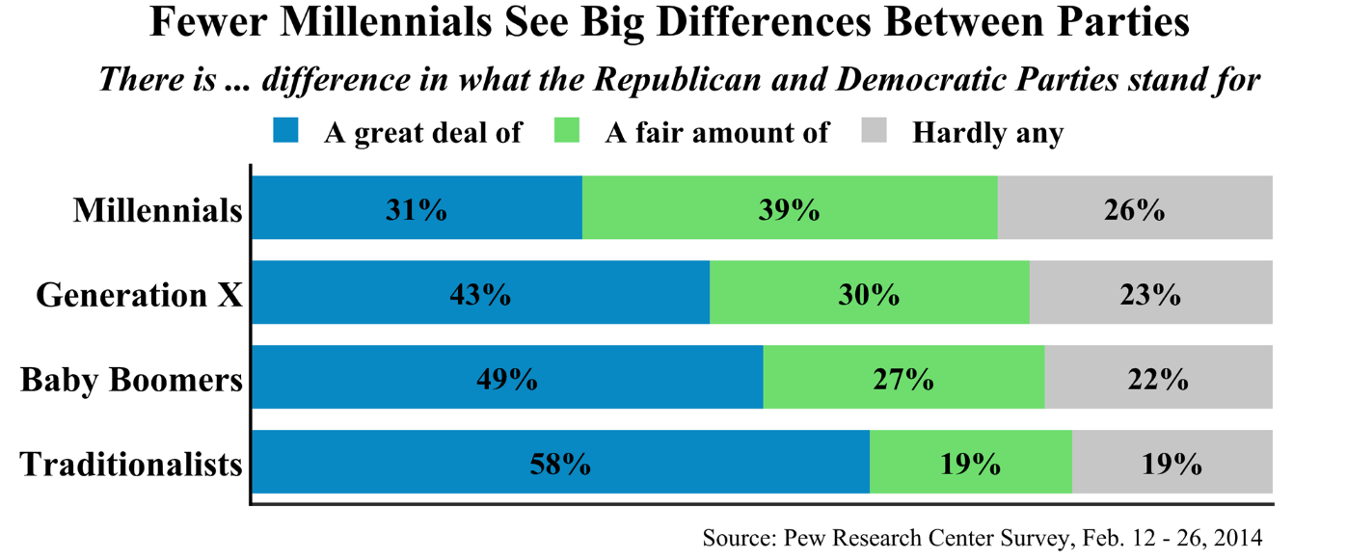

Figure 6. Fewer Millennials See Big Differences Between Parties.

Millennials are simply more critical of politicians. Nearly two-thirds of Millennials think things in the United States are off on the wrong track. Sixty-three percent of Millennials disapprove of the way President Trump is handling his job and 61 percent disapprove of the way Congress is handling its job. Sixty-two percent and 43 percent of Millennials have unfavorable views of Republicans and Democrats, respectively. Stephanie Perry & Andrew Arenge, Poll: Millennials Say the Country is on the Wrong Track, but They’re Not, NBC News (Jan. 29, 2018).

D. Millennials Are Data Connoisseurs

Millennials have grown up with more visual media and competition for attention than previous generations. Using visuals to communicate information is particularly important when speaking to this audience. Stephen Miller, To Reach Millennials, Speak Their (Largely Visual) Language, SHRM (June 20, 2016).

YouTube is now the second most visited website behind Google. The Top 500 Sites on the Web, Alexa (Oct. 24, 2019). When Millennials’ attention starts to wane, 77% of them turn to their phones as compared to 10% of people age 65 or older. Kevin McSpadden, You Now Have a Shorter Attention Span Than a Goldfish, Time (May 14, 2015). While prior generations consumed their news from print, Millennials get their news from the Internet via their phones with information distilled in sound-bite form. The New York Times recently reported that nearly two-thirds of Americans get at least some of their news from social media. Benedict Carey, How Fiction Becomes Fact on Social Media, The New York Times (Oct. 20, 2017). There is evidence from a Pew Research Survey conducted in August 2018 that 18 to 29 years-olds get more of their news from social media than older adults. Elisa Shearer, Social Media Outpaces Print Newspapers in the U.S. as a News Source, Pew Research Center (Dec. 10, 2018). This does not mean they are not information connoisseurs. To the contrary, Millennials are ambitious data seekers. Davis quotes entrepreneur Will Pearson, who has studied this generational demographic, as noting that "Millennials started saving for retirement four years before Gen X did, and 10 years before Baby Boomers." To reach this ambitious generation, Pearson says that you should recognize their intelligence and present information in a fast-paced way to address the ambitiousness. Kathleen Davis, Five Secrets to Communicating Effectively with Millennials, Entrepreneur (June 13, 2013).

There is also credible evidence that Millennials can process more information than members of other generations. As one study noted, “Using the analogy of an 85-page newspaper, they found that in 1986 Americans received around 40 newspapers full of information every day, but this had rocketed to 174 in 2007.” Richard Alleyne, Welcome to the Information Age – 174 Newspapers a Day, The Telegraph (Feb. 11, 2011). In our experience observing Millennials in mock trial research, the desire of this generation to want to conduct independent research about cases and case-related issues stems less from a rebellious nature and more from an inquisitive frame of mind.

E. Millennials And Sexual Abuse Perceptions

Data regarding Millennials and their opinions of sexual abuse is mixed. Research is needed to analyze the effect of the Me Too Movement on perceptions of allegations of child sexual abuse in general and across generational cohorts in particular. What little data exists regarding generational cohort opinions of child sexual abuse is mixed. There is some data to suggest that Millennials are less likely to view sexual abuse as a serious problem. This could be due to the fact they missed the onslaught of media attention on the problem of institutional abuse that older generations viewed. A YouGov poll found that of the 1,234 Americans they surveyed, older generations are more likely to be concerned about sexual abuse in child-education organizations. Fifty-six percent of Millennials and 57% of Gen Xers say this is a problem, compared to 68% of Boomers and 76% of Traditionalists.

However this same survey also tested respondents’ support for reevaluating child abuse allegations against Michael Jackson. The survey asked, “Two men are suing the Jackson estate with allegations of child molestation against Michael Jackson. The cases were dismissed due to the statute of limitations (i.e. the case was determined to be too old) but the men are appealing. Do you think the cases should be reopened?” Nearly half of respondents believed that the cases should not be reopened (48%), 23% supported doing so, and 29% were unsure. Support for reopening the cases was highest among Millennials (31%), followed by Boomers (20%), Traditionalists (19%), and Gen Xers (18%). YouGov, Leaving Neverland, (2019).

This article is for general information purposes and is not intended to be and should not be taken as legal advice.

Some of these four ideas were published in a prior article. Ken Broda-Bahm, Shelley Spiecker, & Kevin Boully, Jury Persuasion in an 'Alt-Fact' World, Law360 (Oct. 17, 2017).

